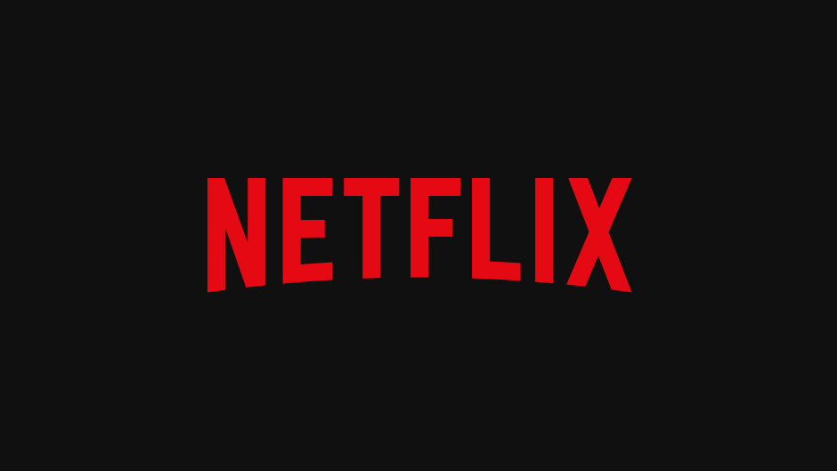

**Product Dissection for Netflix**

### **Company Overview:**

Founded by Reed Hastings and Marc Randolph in 1997, Netflix has emerged as a powerhouse in the entertainment industry. Since its inception, Netflix has redefined how we consume movies and shows, offering a vast selection of content to subscribers worldwide. With features like personalised recommendations, introduced in 2000, Netflix has continually enhanced the user experience. The introduction of instant streaming in 2007 marked a pivotal moment in the company's history, solidifying its position as a leader in digital entertainment. By 2016, Netflix boasted over 50 million subscribers globally, a testament to its unrivalled impact on the industry. Today, under the visionary leadership of Reed Hastings, Netflix remains at the forefront of innovation, captivating audiences with its diverse array of original content and global reach.

### **Product Dissection and Real-World Problems Solved by Netflix:**

Netflix, a pioneering streaming service, has revolutionised the entertainment industry with its innovative approach and commitment to user satisfaction. At the heart of Netflix lies its vast content library, comprising an extensive array of movies, TV shows, documentaries, and original productions. This diverse collection caters to a wide range of tastes and preferences, ensuring that subscribers have access to a wealth of entertainment options.

One of Netflix's standout features is its sophisticated recommendation system, which harnesses machine learning algorithms to analyse user behaviour and preferences. By leveraging data on viewing history, ratings, and interactions, Netflix delivers personalised content suggestions tailored to each user's individual tastes. This not only simplifies the process of content discovery but also enhances the overall viewing experience by presenting users with relevant and engaging titles.

In addition to its recommendation system, Netflix boasts an intuitive and user-friendly interface that facilitates seamless navigation and content exploration across various devices. Whether accessing the platform through a smart TV, computer, or mobile device, subscribers can easily browse through the extensive content library, manage their viewing queues, and discover new favourites with ease.

Furthermore, Netflix's commitment to technological innovation is evident in its advanced streaming technology, which ensures high-quality video playback and reliable streaming performance. By optimising video delivery across different internet connections and devices, Netflix strives to provide a consistently exceptional viewing experience for its subscribers, regardless of their location or device preferences.

Beyond its technological prowess, Netflix also addresses real-world challenges facing the entertainment industry. By offering a legal and affordable alternative to piracy and illegal downloads, Netflix helps combat copyright infringement while supporting content creators and rights holders. Moreover, Netflix's commitment to diversity and inclusion is reflected in its global content library, which features a rich tapestry of stories and perspectives from around the world.

In summary, Netflix's success can be attributed to its robust technology infrastructure, personalised recommendation system, user-friendly interface, and commitment to addressing real-world challenges. As the streaming landscape continues to evolve, Netflix remains at the forefront, reshaping the way audiences consume and engage with media in the digital age.

### **Case Study: Real-World Problems and Netflix's Innovative Solutions**

Netflix, a groundbreaking entertainment platform, has not only transformed the way we access and enjoy content but has also tackled substantial real-world challenges through its innovative offerings. By understanding user preferences and harnessing cutting-edge technology, Netflix has emerged as a solution-oriented platform that fosters entertainment, empowers storytelling, and enriches digital experiences.

#### **Problem 1: Accessibility**

**Real-World Challenge:** Previously before 2007, accessing entertainment content was constrained by fixed TV schedules and the need for physical media like DVDs. Viewers had to adhere to specific broadcast times or visit stores to rent or purchase movies and shows.Moreover, limited by geographical boundaries. Viewers across different regions faced disparities in available content due to licensing agreements and distribution channels. This meant that certain movies or shows might be accessible in one country but unavailable in another, creating frustration and disparity among audiences worldwide. As a result, individuals were often unable to access the full breadth of entertainment options enjoyed by others in different regions., .

**Netflix's Solution:**

Netflix revolutionised this landscape by offering a vast digital library that users can access instantly, regardless of location or time zone, via internet-connected devices.This on-demand model liberates viewers from the confines of traditional television schedules, enabling them to indulge in their favourite movies and shows at their convenience. Moreover, Netflix's elimination of physical media obviates the need for DVD players and the inconvenience of returning rented discs, streamlining the viewing experience.

Furthermore, Netflix's global accessibility transcends geographical boundaries, empowering users worldwide to explore diverse content without the constraints of regional limitations. Its platform adapts to users' preferences, providing a personalised viewing journey that enriches their entertainment experience.

#### **Problem 2: Content Discovery**

**Real-World Challenge:** The process of discovering new and relevant content was often cumbersome and time-consuming for viewers. Without personalised suggestions, users had to rely on generic recommendations or manually sift through vast libraries of movies and shows to find something of interest. This process could be overwhelming and inefficient, leading to frustration and potentially causing users to miss out on content they would enjoy.

**Netflix's Solution:**

Netflix employs a sophisticated recommendation algorithm that analyses user viewing history, ratings, and preferences to suggest personalised content, enhancing user experience and engagement. By providing personalised recommendations, Netflix streamlines the content discovery process, making it easier for users to explore new titles and discover content that resonates with their interests and tastes.

#### **Problem 3: Piracy and Illegal Downloads**

**Real-World Challenge:** The unauthorised sharing and distribution of copyrighted content. Before platforms like Netflix, people often shared movies and shows illegally, which violated copyright laws and deprived content creators and rights holders of their rightful earnings. This unauthorised distribution harmed the creators financially and undermined the integrity of intellectual property rights. .

**Netflix's Solution:**

Netflix's solution to this problem is to provide a legal and ethical platform for consumers to access a wide range of content. By offering a subscription-based service with licensed content, Netflix discourages unauthorised distribution and supports content creators and rights holders by ensuring they receive fair compensation for their work. This model benefits both content creators and consumers, promoting a more sustainable and ethical approach to content consumption.

#### **Problem 4: Advertisements:**

**Real-World Challenge:** Traditional TV broadcasts often interrupted shows with advertisements, disrupting the viewing experience.

**Netflix's Solution:**

Netflix solved the problem of interruptions by advertisements through its subscription-based model. Unlike traditional TV broadcasts, Netflix does not interrupt shows or movies with advertisements. Instead, subscribers pay a monthly fee for access to the entire library of content without any interruptions. This allows viewers to enjoy their favourite shows and movies without the disruption of commercials, enhancing the overall viewing experience and providing uninterrupted entertainment.

#### **Conclusion:**

Netflix's evolution from a DVD rental service to a global streaming platform exemplifies its adeptness at identifying and addressing real-world challenges through innovative solutions. By revolutionising how people access and consume entertainment content, Netflix has transcended traditional media boundaries and reshaped the digital landscape. Through personalised recommendations, diverse content offerings, original productions, and global accessibility, Netflix has tackled various obstacles that users face in the modern entertainment landscape. This case study underscores how Netflix's customer-centric approach and commitment to innovation have propelled it to the forefront of the streaming industry, fundamentally altering the way audiences engage with media and entertainment online.

### **Top Features of Netflix:**

1. **Vast Content Library:** Netflix provides subscribers with access to a vast library of movies, TV shows, documentaries, and original content across various genres and languages.
2. **Streaming on Multiple Devices:** Subscribers can stream Netflix content on a wide range of devices, including smartphones, tablets, computers, smart TVs, gaming consoles, and streaming media players.
3. **Ad-Free Viewing:** Unlike traditional TV broadcasts, Netflix does not interrupt shows or movies with advertisements, allowing for uninterrupted viewing.
4. **Original Content:** Netflix produces and distributes a diverse range of original movies, TV series, documentaries, and stand-up specials, known as "Netflix Originals," which are exclusive to the platform.
5. **Multiple Profiles::** Users can create multiple profiles within a single Netflix account, allowing each member of the household to have their own personalised viewing experience with separate watchlists, recommendations, and viewing history.
6. **Offline Viewing:** Netflix offers the option to download select titles for offline viewing, allowing subscribers to watch content without an internet connection.

### **Schema Description:**

The schema for Netflix involves multiple entities that represent different aspects of the platform. These entities include Users, Movies, TV Shows, Genres, Watch History etc. Each entity has specific attributes that describe its properties and relationships with other entities.

**User Entity:**

Users are fundamental to Netflix's platform. The user entity contains information about each user:

* **UserID (Primary Key)**: A unique identifier for each user.
* **Username**: The chosen username for the user's account.
* **Email**: The user's email address for account-related communication.
* **Subscription_Type**:.Indicates the type of subscription the user has (e.g., Basic, Standard, Premium).
* **Payment_Method**: The user's preferred payment method.
* **Subscription_Start_Date**: The date when the user's subscription started.
* **Subscription_End_Date**: The date when the user's subscription ends.

**Movie Entity**:

Movies represent the individual films available on Netflix. This entity contains details about each movie:

* **MovieID (Primary Key)**: A unique identifier for each movie.
* **Title**: The title of the movie.
* **Release_Date**: The date when the movie was released.
* **Duration**: The length of the movie in minutes.
* **Director(s)**: The director(s) of the movie.
* **Description**: A brief summary of the movie's plot.
* **Average_Rating**: The average rating given to the movie by users.

**TV Show Entity**:

TV shows are series with multiple episodes available for streaming. This entity includes information about each TV show:

* **ShowID (Primary Key)**: A unique identifier for each TV show.
* **Title**: The title of the TV show.
* **Release_Date**: The date when the TV show was first released.
* **Seasons**: The total number of seasons available for the TV show.
* **Episodes**: The total number of episodes across all seasons.
* **Creators**: The creators of the TV show.
* **Description**: A brief summary of the TV show's plot.

**Genre Entity**:

Genres categorise content based on themes, styles, or subject matter. This entity contains information about different genres:

* **GenreID (Primary Key)**: A unique identifier for each genre.
* **Name**: The name of the genre (e.g., Action, Comedy, Drama).
* **Description**: A brief description of the genre and its characteristics.

**Watch History Entity**:

The watch history entity keeps track of users' viewing activities:

* **WatchID (Primary Key)**: A unique identifier for each watch history entry.
* **UserID (Foreign Key)**: The ID of the user who watched the content.
* **MovieID (Foreign Key)**: The ID of the movie watched.
* **ShowID (Foreign Key)**: The ID of the TV show watched.
* **Timestamp**: The date and time when the content was watched.
* **Duration_Watched**: The duration of the content watched by the user.

**Payment Entity**:

The Payment entity contains information related to users' payment transactions and methods:

* **PaymentID (Primary Key)**: A unique identifier for each payment transaction.
* **UserID (Foreign Key)**: The ID of the user making the payment.
* **Payment_Method**: The method used for payment (e.g., credit card, PayPal, direct debit).
* **Card_Number**: The masked or encrypted card number used for payment.
* **Expiration_Date**: The expiration date of the payment method.
* **Billing_Address**: The billing address associated with the payment method.
* **Amount**: The amount paid by the user for the subscription.
* **Payment_Date**: The date and time when the payment transaction occurred.
* **Payment_Status**: The status of the payment transaction (e.g., success, pending, failed).

**Relationships are:**

* **Users watch Movies/TV Shows** **–** Each user can watch multiple movies and TV shows.
* **Users add Movies/TV Shows to Watchlist –** Users can add multiple movies and TV shows to their watchlist, and each movie or TV show can be added to multiple users' watchlists.
* **Users subscribe to Plans –** Users can subscribe to one subscription plan at a time, and each subscription plan can have multiple subscribers.
* **Movies/TV Shows belong to Genres –** Each movie or TV show can belong to multiple genres, and each genre can be associated with multiple movies or TV shows.

**ER Diagram:**

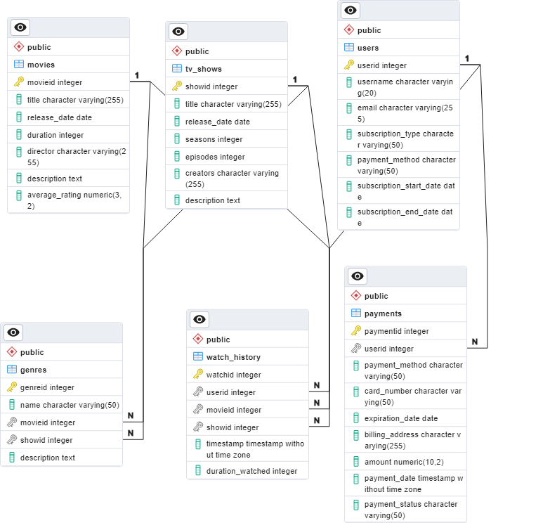

### **Conclusion**

In this case study, we delve into Netflix's Entity-Relationship (ER) diagram, which serves as the blueprint for its personalised entertainment platform. At its core, the User entity encapsulates user profiles, subscription data, and payment preferences, enabling Netflix to tailor recommendations based on individual viewing histories. The Movie and TV Show entities enrich the platform's content library, while genres facilitate seamless content discovery. The Watch History entity tracks user interactions, empowering Netflix to refine its recommendation algorithms and deliver a compelling viewing experience tailored to each user's preferences. Through its sophisticated schema, Netflix redefines entertainment consumption, setting the standard for personalised streaming services globally.